**Assignment -1**

**1. Return the categories (names) of the longest film. NOTE that there may be several "longest"**

**films (i.e. with the same length), so you might need to return more than one category. Return**

**the duration as well.**

**SQL Used:**

**select category, length from film_list where length in(select max(length) from film_list);**

**Output:**

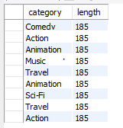

**Screenshot:**

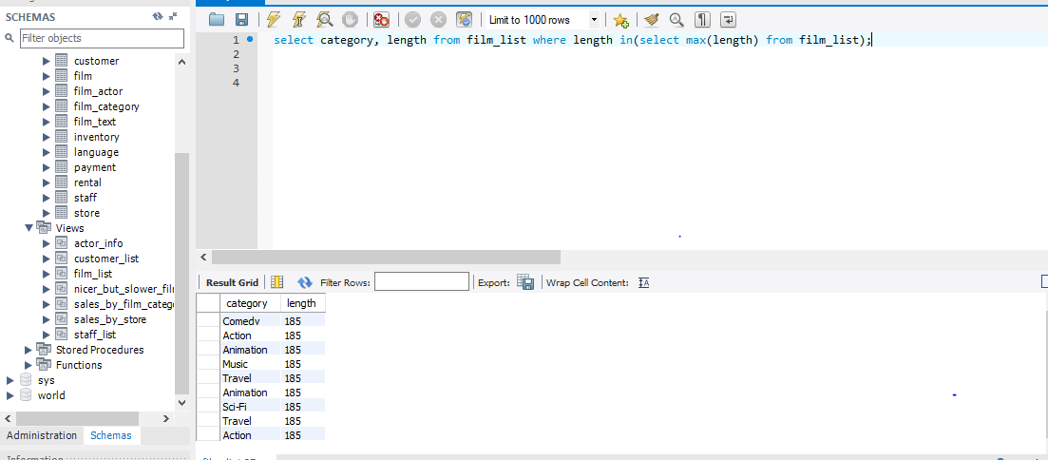

**2. Find the movies whose total number of actors is above the average. Return the movie names**

**and its number of actors ordered by the title. IMPORTANT NOTE: this query should return many**

**movies. Please write in your submission only the first TOP-10 results.**

**SQL Used:**

**create table modified_actor as select title,count(actor_id) as Number_Of_Actor, film.film_id from film_actor, film where film.film_id=film_actor.film_id group by film.film_id;**

**select * from modified_actor;**

**select title, Number_Of_Actor from modified_actor where Number_Of_Actor > (select avg(Number_Of_Actor) from modified_actor) limit 10;**

**Output:**

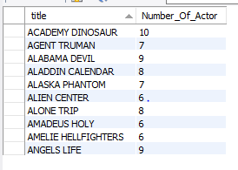

**Screenshot:**



    
    
    
    
    
    
    
    
    
    
    
    
    
    
    
    
    
    
    
    
    
    
    
    
    
    
    
    
    
    
    
    
    
    
    
    
    
    
    
    
    
    
    
    
    
    
    
    
    
    
    
    
    
    
    
    
    
    
    
    
    
    
    
    
    
    
    
    
    
    
    
    
    
    
    
    
    
    
    
    
    
    
    
    
    
    
    
    
    
    
    
    
    
    
    
    
    
    
    
    
    
    
    
    
    
    
    
    
    
    
    
    
    
    
    
    
    
    
    
    
    
    
    
    
    
    
    
    
    
    
    
    
    
    
    
    
    
    
    
    
    
    
    
    
    
    
    
    
    
    
    
    
    
    
    
    
    
    
    
    
    
    
    
    
    
    
    
    
    
    
    
    
    
    
    
    
    
    
    
    
    
    
    
    
    
    
    
    
    
    
    
    
    
    
    
    
    
    
    
    
    
    
    
    
    
    
    
    
    
    
    
    
    
    
    
    
    
    
    
    
    
    
    
    
    
    
    
    
    
    
    
    
    
    
    
    
    
    
    
    
    
    
    
    
    
    
    
    
    
    
    
    
    
    
    
    
    
    
    
    
    
    
    
    
    
    
    
    
    
    
    
    
    
    
    
    
    
    
    
    
    
    
    
    
    
    
    
    
    
    
    
    
    
    
    
    
    
    
    
    
    
    
    
    
    
    
    
    
    
    
    
    
    
    
    
    
    
    
    
    
    
    
    
    
    
    
    
    
    
    
    
    
    
    
    
    
    
    
    
    
    
    
    
    
    
    
    
    
    
    
    
    
    
    
    
    
    
    
    
    
    
    
    
    
    
    
    
    
    
    
    
    
    
    
    
    
    
    
    
    
    
    
    
    
    
    
    
    
    
    
    
    
    
    
    
    
    
    
    
    
    
    
    
    
    
    
    
    
    
    
    
    
    
    
    
    
    
    
    
    
    
    
    
    
    
    
    
    
    
    
    
    
    
    
    
    
    
    
    
    
    
    
    
    
    
    
    
    
    
    
    
    
    
    
    
    
    
    